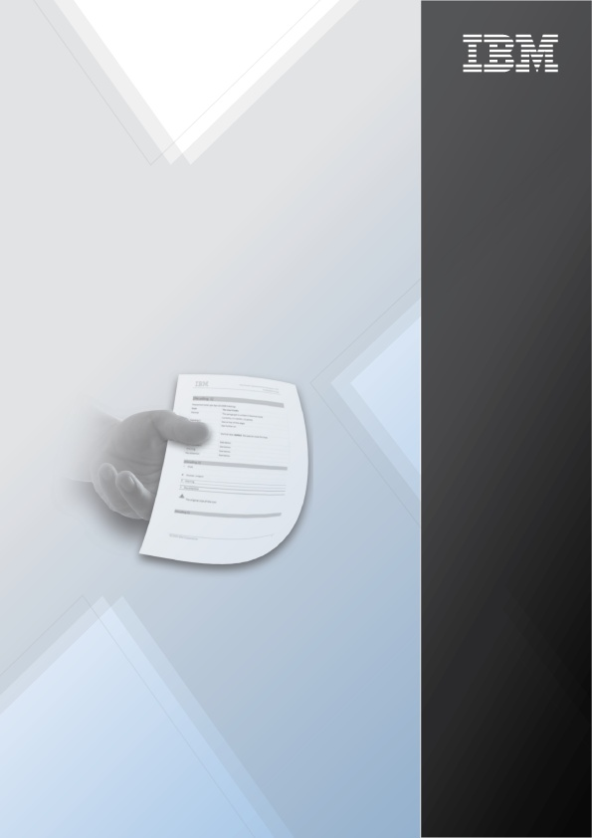

IBM System Storage TS7600 with ProtecTIER
Release Notes

Version 3.2.3

© Copyright IBM Corporation 2011, 2012. US Government Users Restricted Rights - Use, duplication or disclosure restricted by GSA ADP Schedule Contract with IBM Corp.
References in this documentation to IBM® products, programs, or services do not imply that IBM intends to make these available in all countries in which IBM operates. Any reference to an IBM product, program or service is not intended to state or imply that only IBM's product, program or service may be used. Any functionally equivalent product, program or service that does not infringe any of IBM's intellectual property rights may be used instead of the IBM product, program or service. Evaluation and verification of operation in conjunction with other products, except those expressly designated by IBM, are the user's responsibility.

Table of Contents
Release notes 1
Introduction 1
Prerequisites 1
Code levels 1
New features and resolved problems 2
Installation Instructions 8
Upgrading the ProtecTIER software 8
Additional documentation 10
Restrictions and known issues 11
Compatibility 13
Documentation format and accessibility 14
Notices and trademarks 15
Notices 15
Trademarks 15
THIRD-PARTY LICENSE TERMS AND CONDITIONS, NOTICES AND INFORMATION 15

Release notes
These release notes are for IBM System Storage TS7600 with ProtecTIER Software, version 3.2.3.
Release date 10 January 2012.

Introduction

This document is a reference for installation and upgrades and contains other useful information about the IBM System Storage TS7600 with ProtecTIER v3.2.3.

Prerequisites

Prerequisites include the following:
- ProtecTIER Manager V3.2.X must be installed.
- RedHat code level 5.6 must be installed on the system first. The upgrade to V3.2.3 will fail if RedHat version 5.6 is not installed first. If the system is already running RedHat 5.6, then 3.2.3 can be downloaded from the Fix Central Website.
http://www-933.ibm.com/support/fixcentral/
- The full package code must have already been installed on the system. Installation of this patch on a Linux OS system will fail without the full package code already being installed.

Code levels

Code level requirements include the following:
Software | Version
ProtecTIER software level | 3.2.3
Dtcemulex | 5232.005-0
Ptlinux | 7132.092-0
Ptrepmgr | 6132.085-0

New features and resolved problems

The ProtecTIER Introduction and Planning Guides describe the new features in the release:
IBM System Storage TS7650 ProtecTIER 3.2 Deduplication Appliance and TS7650G Deduplication Gateway Introduction and Planning Guide (3958-AP1 and 3958-DD5) (GA32-0918)
Or
IBM System Storage® TS7610 and TS7620 ProtecTIER® 3.2 Deduplication Appliance Express Introduction and Planning Guide (GA32-0913)
See the Additional documentation section of this document for information about how to find these publications.

ProtecTIER Server issues:
Issue ID | Fix ID | Description
 | 81023672, 81023600 | Added support for new model of ethernet card to SM2.
16775 | 81021353 | Updated memory requirments for SM2
20325 | 81023269 | Solved replication failures in Veeam environment.
 | 81023353 | Added dspf rollback mechanism in case of DSO_MSG_FAULT issue during incoming replication.
 | 81023162 | The replication performance degradation issue in Many-To-Many envronments was solved by support the option to configure the number of incoming/outgoing replicators within NR configuration files. Contact IBM support for this action.
18422 | 81021975 | Solved issue when FSI manual replication is slow after trigger queue entered retry mode.
20683 | 81023676 | Solved backup failures as a result CRC mistmach error.
20666 | 81023700 | Solved replication activities issue during stress.

ProtecTIER driver issues:
Issue ID | Fix ID | Description

ProtecTIER Manager issues:
Issue ID | Fix ID | Description

Installation Instructions

The installation roadmaps contain complete installation instructions for VTL, OpenStorage, or FSI systems:
- IBM System Storage TS7620 ProtecTIER® v3.2 Deduplication Appliance Express Installation and Setup Guide for VTL, OpenStorage, and FSI Systems (GA32-0914)
- IBM System Storage TS7650 ProtecTIER® v3.2 Deduplication Appliance Installation Roadmap Guide, 3958 AP1 (GA32-0920)
- IBM System Storage TS7650G ProtecTIER® v3.2 Deduplication Gateway Installation Roadmap Guide, 3958 DD5 (GA32-0921)
See the Additional documentation section of this document for information about how to find these publications.

Upgrading the ProtecTIER software
Concurrent upgrades for this version are not supported.
Important: For all upgrades or updates, follow the instructions exactly as written, including when to stop and start vtfd and ptcluster services for each node.
For TS7610 or TS7620 Appliance Express systems, use the IBM System Storage® TS7610 and TS7620 ProtecTIER® v.3.2 Deduplication Appliance Express Software Upgrade Guide (SC27-3641) and choose one of the following options:
- Upgrading a TS7610 or TS7620 system from v3.1.8 or higher (Option A)
To upgrade to v3.2.3 from v3.1.8 or above, follow the procedure described in Chapter 3, "Upgrading the ProtecTIER software to version 3.2 from version 3.1.8 or higher" in the IBM System Storage TS7610 and TS7620 Appliance Express ProtecTIER v. 3.2 Software Upgrade Guide (SC27-3641-03).
- Upgrading a TS7610 or TS7620 system from v3.1.X (any 3.1 version below 3.1.8) or v2.5.X (Option B)
To upgrade to v3.2.3 from v3.1.x (any 3.1 version below 3.1.8) or v2.5, follow the procedure described in Chapter 4, "Upgrading Red Hat Linux and ProtecTIER" in the IBM System Storage TS7610 and TS7620 Appliance Express ProtecTIER v. 3.2 Software Upgrade Guide (SC27-3641-03).
- Updating a TS7610 or TS7620 system already at v3.2. with a fix update or patch (Option C)
Update a system already at v3.2 with a later fix update or patch by using the procedure described in Chapter 6, “Applying fixes to update the ProtecTIER software for version 3.2 and higher” in the IBM System Storage TS7610 and TS7620 Appliance Express ProtecTIER v. 3.2 Software Upgrade Guide (SC27-3641-03).

For TS7650 Appliance or TS7650G (Gateway) systems, use the IBM System Storage TS7650 ProtecTIER v. 3.2 Software Upgrade Guide (SC27-3643) and choose one of the following options:
- Upgrading a TS7650 or TS7650G system from v3.1.8 or higher (Option A)
To upgrade to v3.2.3 from v3.1.8 or above, follow the procedure described in Chapter 3, "Upgrading the ProtecTIER software to version 3.2 from version 3.1.8 or higher" in the IBM System Storage TS7650 ProtecTIER v. 3.2 Software Upgrade Guide (SC27-3643-03).
- Upgrading a TS7650 or TS7650G system from v3.1.X (any 3.1 version below 3.1.8), v2.5.X or v2.4.X (Option B)
To upgrade to v3.2.3 from v3.1.x (any 3.1 version below 3.1.8), v2.5, or v2.4, follow the procedure described in Chapter 4, "Upgrading Red Hat Linux and ProtecTIER for servers before version 3.1.8" in the IBM System Storage TS7650 ProtecTIER v. 3.2 Software Upgrade Guide (SC27-3643-03).
- Upgrading a TS7650 or TS7650G system from v2.3.x or v2.2.x (Option C)
First upgrade to v2.4, then to v3.2.
Upgrade to v2.4 by using the procedure described in Chapter 6, "Upgrading and Configuring Red Hat Linux and ProtecTIER" of the IBM System Storage TS7600 with ProtecTIER Software Upgrade and Replication Enablement Guide (GC53-1196-02).
Upgrade to v3.2.3 as described in Option B.
- Updating a TS7650 or TS7650G system already at v3.2 with a fix update or patch (Option D)
Update a system already at v3.2 with a later fix update or patch by using the procedure described in Chapter 6, “Applying fixes to update the ProtecTIER software for version 3.2 and higher” in the IBM System Storage TS7650 ProtecTIER v. 3.2 Software Upgrade Guide (SC27-3643-03).

Additional documentation

All ProtecTIER publications can be found in the IBM Publications Center. To access all publications, go to:
http://www-05.ibm.com/e-business/linkweb/publications/servlet/pbi.wss
- Select your country/region/language.
- Select Search for publications in the left menu.
- Search for the publications by publication title, keyword (for example, ProtecTIER), or form number.
ProtecTIER Information Centers are available at the following at the following locations:
Information Center | URL
TS7610 and TS7620 Combined Customer Information Center | http://pic.dhe.ibm.com/infocenter/ts7610/cust/index.jsp
TS7650 Combined Customer Information Center | http://pic.dhe.ibm.com/infocenter/ts7650/cust/index.jsp
TS7610, TS7620, and TS7650 Combined Service Information Center | http://pic.dhe.ibm.com/infocenter/ts7600/serv/index.jsp

Restrictions and known issues

Restrictions and known issues include the following:
- Before performing any configuration operation, upgrade both nodes to the same patch level.
- Do not move a cartridge from the shelf of the remote repository while it is the target of a replication operation.

Issue ID | Description | Workaround
15607 | Increase capacity failures are experienced. | Contact IBM support.
16269, 17670, 17524, 17353 | The Temporary Restore/Replication fails (rare) | Retry the operation.
16556 | A failover to a secondary active directory may fail to work automatically. | Manually configure the primary active directory.
16895 | The system may hang after the SAN is disconnected from Back End Storage (rare). | Reboot the ProtecTIER system.
17168 | The last modified date and sync time might not be accurate on FSI files in replication destination. | N/A
17252 | A Check & Recover failure is experienced when all of the storage units on a specific Back End Storage file system are detached. | Contact IBM support.
17303 | When changing the IP address of an FSI interface, shares become unavailable on that port. | Restart the ProtecTIER system.
17308 | A delayed RCSN may cause VTL to disconnect from the initiator in an IBM i NPIV environment. | Restart the ProtecTIER system.
17360 | The log floods with errors when repository is full. | Contact IBM support.
17421 | FSI traffic might flow through the customer external network. | Separate the FSI network from the external network by using different subnets and VLANs.
17429 | A DD4 NIC replacement may fail. | Contact IBM support.
17531 | VTL is slow to respond to backup commands and eventually backup failure (rare). | Retry the backup jobs and if they still fail, contact IBM support.
17534 | The VTL emulation process crashes (very rare). | Automatic reboot.
17688 | The Tivoli Storage Manager (TSM) backup fails (very rare) | Retry the backup.
17859 | The suspend was increased by 1 hour. | It should be fixed in the 3.2.4 PGA version.

Compatibility

Compatibility requirements include the following:
- ProtecTIER v3.2.3 works with TSSC code level 5.12.8 or later.
- ProtecTIER v3.2.3 requires the use of ProtecTIER Manager V3.2.X
- ProtecTIER Manager versions earlier than v3.2.2 are not compatible with ProtecTIER v3.2.3. Communication between the two will fail.
- Replication is supported from ProtecTIER v2.4 and later. TS7610 Appliance Express v2.1 systems are also supported.
- Replication between ProtecTIER v2.3 and ProtecTIER v3.1.8 and above is NOT supported.
- Replication configuration operations require the use of Replication Manager V3.2 or later ProtecTIER software.
OpenStorage compatibility:
ProtecTIER v3.2.3 is compatible with OpenStorage plug-in 2.5.0.0 and later. OpenStorage plug-in v3.2 is compatible with ProtecTIER v2.5 and later.
Compatibility matrix:
The compatibility matrix can be found at:
http://www-03.ibm.com/systems/storage/tape/library.html#interoperability
under the “TS7650/TS7650G ISV and interoperability matrix” heading.

Documentation format and accessibility
The publications for this product are in Adobe Portable Document Format (PDF) and should be compliant with accessibility standards.
If you experience difficulties when you use the PDF files and want to request a web-based format or accessible PDF document for a publication, send a request by email to starpubs@us.ibm.com. In the request, be sure to include the IBM publication number and title.
When you sent information to IBM, you grant IBM a nonexclusive right to use to distribute the information in any way it believes appropriate without incurring any obligation to you.

Notices and trademarks

Notices
INTERNATIONAL BUSINESS MACHINES CORPORATION PROVIDES THIS PUBLICATION "AS IS" WITHOUT WARRANTY OF ANY KIND, EITHER EXPRESS OR IMPLIED, INCLUDING, BUT NOT LIMITED TO, THE IMPLIED WARRANTIES OF NON-INFRINGEMENT, MERCHANTABILITY OR FITNESS FOR A PARTICULAR PURPOSE. Some jurisdictions do not allow disclaimer of express or implied warranties in certain transactions, therefore, this statement may not apply to you. This information could include technical inaccuracies or typographical errors. Changes are periodically made to the information herein; these changes will be incorporated in new editions of the publication. IBM may make improvements and/or changes in the product(s) and/or the program(s) described in this publication at any time without notice.

Trademarks
Linux is a trademark of Linus Torvalds in the United States, other countries, or both. Microsoft, Windows, and Windows Server are trademarks of Microsoft Corporation in the United States, other countries, or both. Intel, Intel logo, Intel Inside, Intel Inside logo, Intel Centrino, Intel Centrino logo, Celeron, Intel Xeon, Intel SpeedStep, Itanium, and Pentium are trademarks or registered trademarks of Intel Corporation or its subsidiaries in the United States and other countries. Other company, product, or service names may be trademarks or service marks of others.

THIRD-PARTY LICENSE TERMS AND CONDITIONS, NOTICES AND INFORMATION
The license agreement for this product refers you to this file for details concerning terms and conditions applicable to third party software code included in this product, and for certain notices and other information IBM must provide to you under its license to certain software code. The relevant terms and conditions, notices and other information are provided or referenced below. Please note that any non-English version of the licenses below is unofficial and is provided to you for your convenience only. The English version of the licenses below, provided as part of the English version of this file, is the official version. Notwithstanding the terms and conditions of any other agreement you may have with IBM or any of its related or affiliated entities (collectively "IBM"), the third party software code identified below are "Excluded Components" and are subject to the following terms and conditions:
- The Excluded Components are provided on an "AS IS" basis
- IBM DISCLAIMS ANY AND ALL EXPRESS AND IMPLIED WARRANTIES AND CONDITIONS WITH RESPECT TO THE EXCLUDED COMPONENTS, INCLUDING, BUT NOT LIMITED TO, THE WARRANTY OF NON-INFRINGEMENT OR INTERFERENCE AND THE IMPLIED WARRANTIES AND CONDITIONS OF MERCHANTABILITY AND FITNESS FOR A PARTICULAR PURPOSE
- IBM will not be liable to you or indemnify you for any claims related to the Excluded Components
- IBM will not be liable for any direct, indirect, incidental, special, exemplary, punitive or consequential damages with respect to the Excluded Components.

