Problem :

PMR 05141,L6Q,000: Illegal Argument Exception

Problem Reported
Exception is thrown when a user tries to login to the fabric 6.1.2 tools app which is configured to use ldap. The below mentioned exception arises only when a user tries to logon to the tools application for the first time only and work fine on subsequent login.

com.webify.wsf.engine.policy.PolicyException: java.lang.IllegalArgumentException:
Cannot use overly broad dimension:
http://www.w3.org/2002/07/owl#Class(http://www.webifysolutions.com/2005/10/catalog/service#WebServiceChannel
= http://www.webifysolutions.com/2005/10/catalog/service#Channel)
at com.webify.wsf.engine.policy.impl.PolicyManagerImpl.buildPolicy(Unknown Source)
at com.ibm.ws.fabric.da.impl.DaPolicyBuilderImpl.buildPolicy(Unknown Source)
at com.ibm.ws.fabric.da.impl.DynamicAssemblerImpl.buildPolicy(Unknown Source)
at com.ibm.ws.fabric.da.simulation.DaInteraction.doBuildPolicy(Unknown Source)
at com.ibm.ws.fabric.da.simulation.MediationSimulator.simulateBuildSelectionPolicy(Unknown Source)
at com.ibm.ws.fabric.da.simulation.MediationSimulator.simulate(Unknown Source)
at com.ibm.ws.fabric.studio.core.simulation.EndpointSelectionSimulator.simulate(Unknown Source)

Defect(s) Found
LocalVmmProvider class was treating all the federated User attributes as String type. Some of the attributes are stored as List type too and hence if one of the user attribute type is other then String the code fails resulting in above exception being thrown.

Fixes Made
- Modified com.ibm.ws.fabric.vmm.LocalVmmProvider class located in fabric-federation-vmm-8.0.jar to check the property type for all the user attributes before retrieving and adding its value into the FederatedObject.
- Following JAR has been released
fabric-federation-vmm-8.0.jar

Installing Fixes
- If Websphere Process Server is not already running, start it.
- Select Fabric Engine application and click “Update” button.
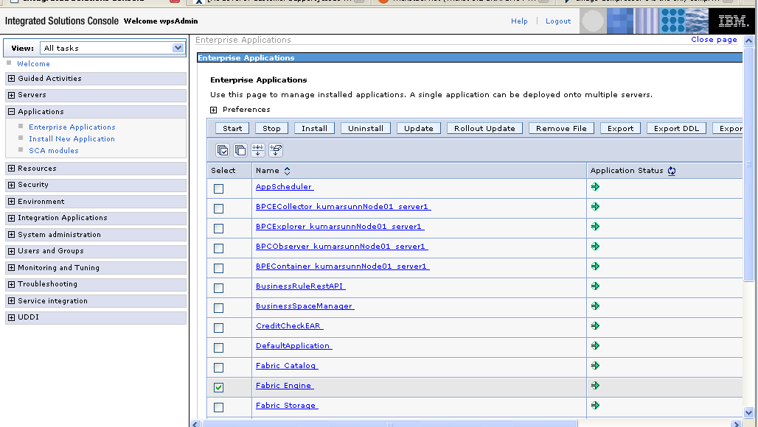

- Select the option “Replace or add a single file”

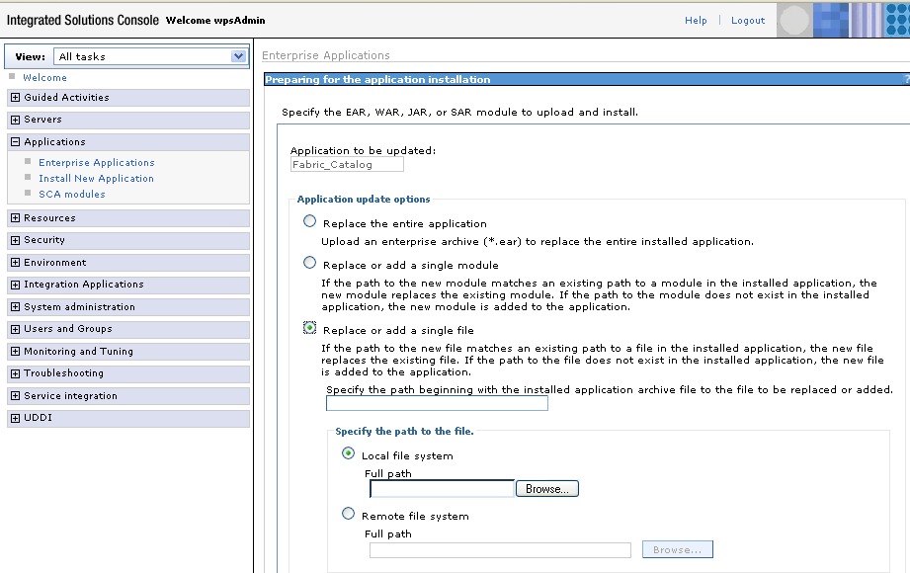

- Specify the path beginning with the installed application archive to the file to be replaced as /lib/fabric-federation-vmm-8.0.jar
- Click browse and select the updated fabric-federation-vmm-8.0.jar file and click next.
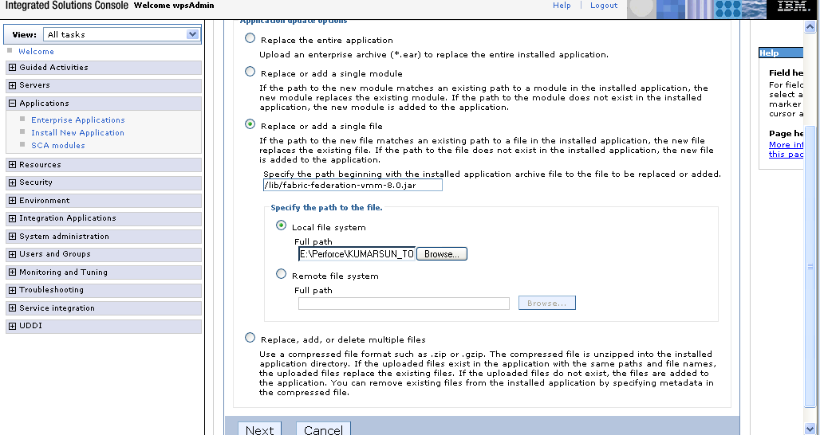

- Click OK

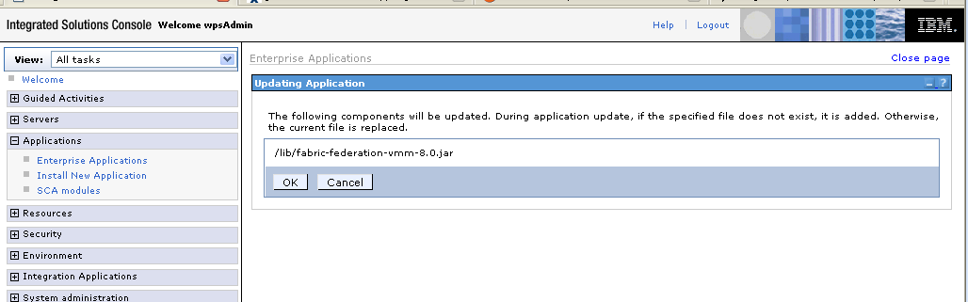

- Click Manage Applications

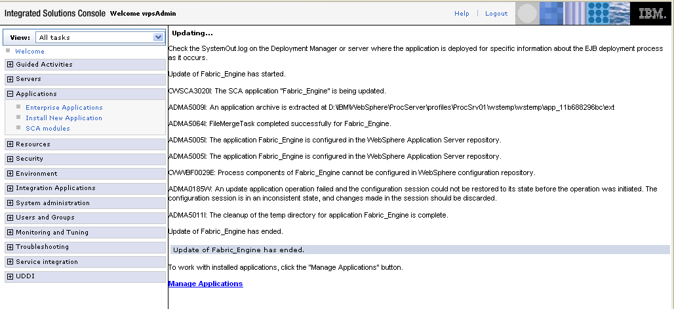
8. Finally click Save to save the changes. This will restart the Fabric Engine application.
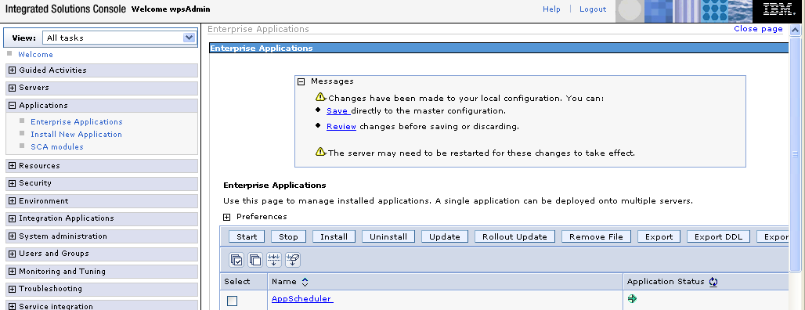
9. Repeat steps 2 to 8 for the remaining 2 ears i.e Fabric_Catalog & Fabric_Tools.

