Problem : PMR 441458, 756, 000 : Sub context creation fails for one way invocation if there are multiple DAs

WebSphere Business Services Fabric Tool Pack 6.1.2 and WebSphere Business Services Fabric Foundation Pack 6.1.2 fail to create sub-Contexts for one-way invocations when a Context Keep Alive assertion is provided.
Windows
WebSphere Business Services Fabric Tool Pack 6.1.2
WebSphere Business Services Fabric Foundation Pack 6.1.2
WebSphere Integration Developer 6.1.2
WebSphere Process Server Test Environment 6.1.2
WebSphere Business Modeler 6.1.2
Rational Software Architect 7.0.0.6
Installation Manager 1.1.2
===============================================================

Solution :
The Context manager implementation in the fabric-context-impl-8.0.jar has been updated such that sub-Context creation that relies on Context Keep Alive assertion will now work. In addition to updating this jar file in the Fabric-Engine EAR, Result Caching must be disabled for the Dynamic Assembly component to which the Context Keep Alive assertion pertains.
To update the Fabric-Engine EAR:
- Launch the WPS admin console.
- Select Fabric Engine application and click Update.
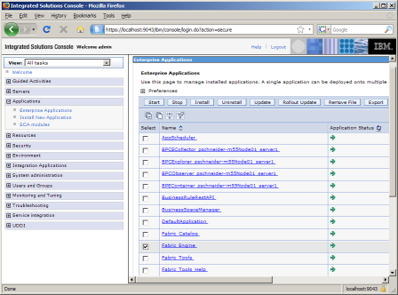
- Select the option Replace or add a single file
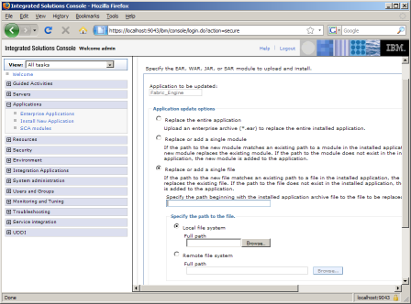
- Specify the path beginning with the installed application archive to the file to be replaced as /lib/fabric-context-impl-8.0.jar
- Click browse and select the updated fabric-context-impl-8.0.jar file and click Next.
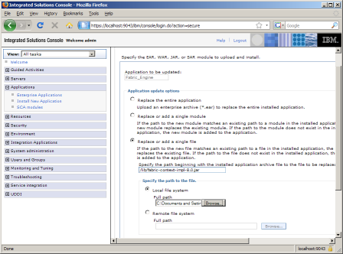
- Click OK to confirm the update.
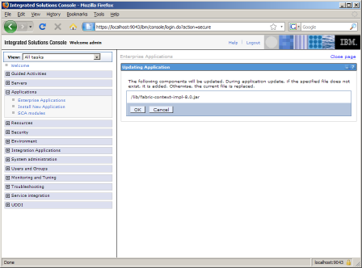
- When the update is done processing, click Manage Applications.
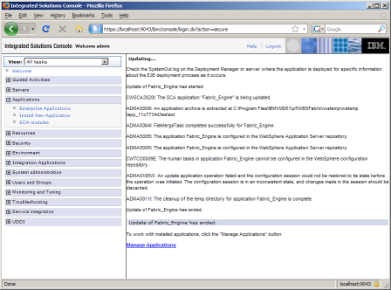
- Finally click Save to save the changes. This will restart the Fabric Engine application.
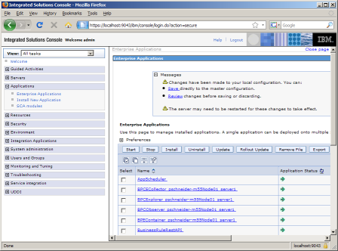

To Disable Result Caching in your DA Component:

- Open the Assembly Diagram in WID and double-click on the Dynamic Assembly component that will be processing the one-way invocations.

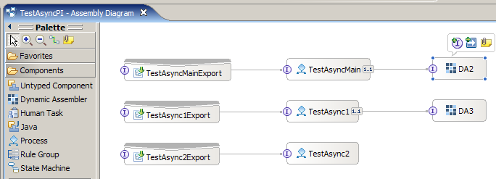

- Disable the Result Cache by removing the checkmark from the Enable Result Caching checkbox.

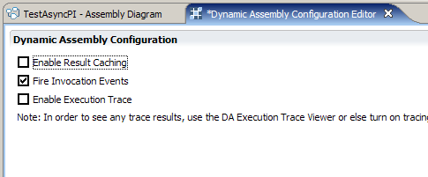

- Save the configuration to your Dynamic Assembly component and re-deploy your application.

